# Home

## Banner

1. HitGen官网中关于OpenDEL的图片（[DNA encoded library | HitGen](https://www.hitgen.com/en)）
2. 后续最新活动的信息

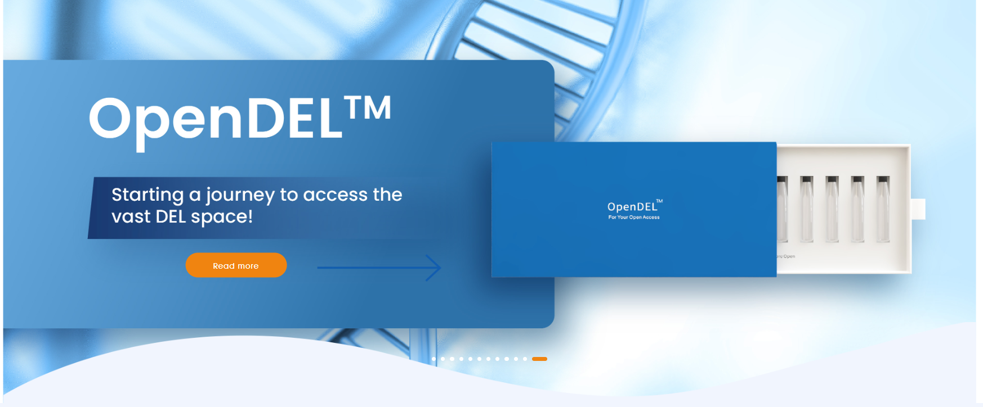

## Service内容

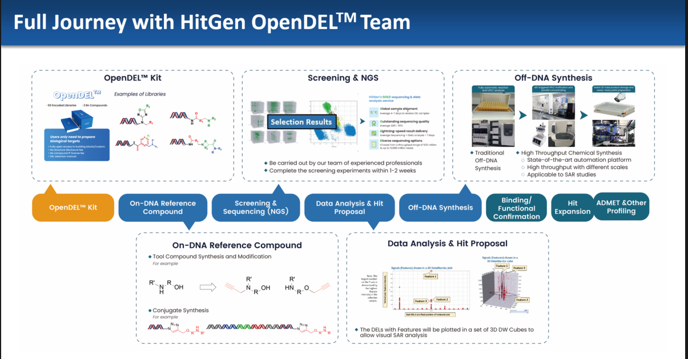

### OpenDEL Kit

Starting a journey to access the vast DEL space

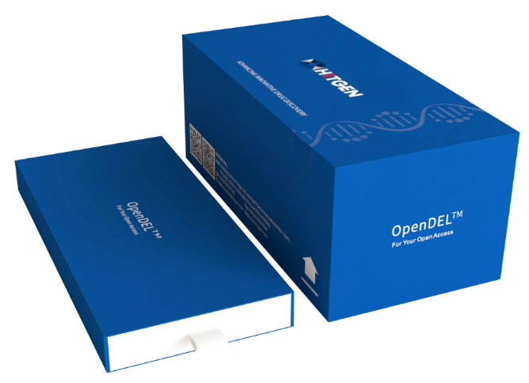

* **The Kit**
  + 50 Libraries
  + 3Bn compounds
  + 10 DEL samples
* **To Access**
  + Fully enumerated molecules
  + Building Block Structures
  + DNA Codon Sequences
  + Scaffolds Information
* **No Structure Disclosure Fee**
* **No Compound IP License Fee**

### OpenDELTM Screening

OpenDEL™ screening is carried out by our team of experienced professionals, proficient in handling over 50 different target types including protein-protein interactions, kinases, enzymes, transcription factors, and RNA targets. Our team typically completes the screening experiments within 1-2 weeks. For more information and to explore detailed stories about our featured target types, click on the images below. We plan to release similar articles for other target classes in the future.

### OpenDELTM Sequencing

**HitGen’s GOLD sequencing & data analysis service**

**Global sample shipment**

Shipping samples to HitGen via Hub.

Average 4-7 days to receive DEL samples

**Outstanding sequencing quality**

Average Q30 > 92%

**Lightning-speed result delivery**

Average Sequencing + Data analysis < 7 days

**Diverse sequencing options**

Choose from a throughput range of 500 million to up to 10,000 million reads

### OpenDELTM Hit Proposal

Analyzing DEL selection data and choosing the right compounds for follow-up necessitates multidisciplinary expertise encompassing biology, computational science, and chemistry. This includes a deep understanding of the experimental design and mechanisms of action (MOAs) in biology, data processing and analysis in computational science, and aspects of both synthetic and DEL chemistry

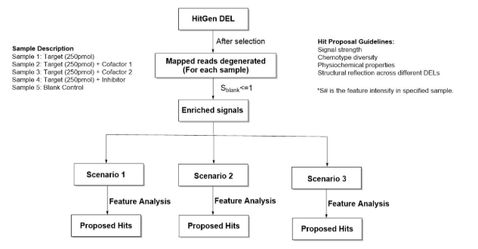

### OpenDELTM Off-DNA Synthesis

Our traditional synthesis service excels at recreating complex chemical structures derived from various DELs. We offer diverse options, including traditional chemistry synthesis service and high-throughput synthesis service.

**A. Traditional Chemical Synthesis @ HitGen**

**B. High Throughput Chemical Synthesis @ HitGen**